ELECTRONICS
ECE 3455
LECTURE NOTES - DAVE SHATTUCK
SET #8

SPECIAL TOPICS

Let’s derive Miller’s Theorem and the Dual to Miller’s Theorem. This is similar to what is given in Section 2.9 in the text.

In Miller’s Theorem, we have a resistance, say Rf, between 2 nodes, where the ratio of the voltages at those nodes is known. Generally, this only happens when we have a voltage-dependent voltage source or something like it.
We call this ratio µ, and then we argue that the outside world cannot tell the difference as long as the currents leaving the two nodes through Rf do not change. We can make this happen by connecting two new resistors, from each of the two nodes to ground, with the appropriate values.
What values would these resistors have? To find the first value, R1, we would note that the same current must go through R1 in its new position, as went through Rf before. Thus,
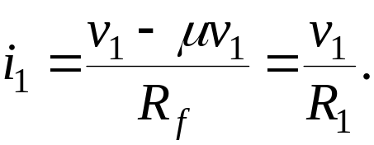
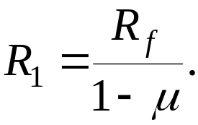 If we solve this for R1, we get
Now, let’s solve for R2. We follow the same approach, and find that
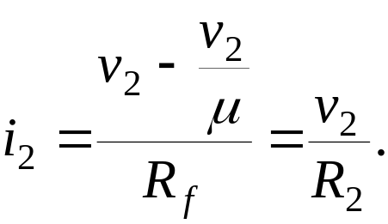
Now, again, we can solve for R2, and get
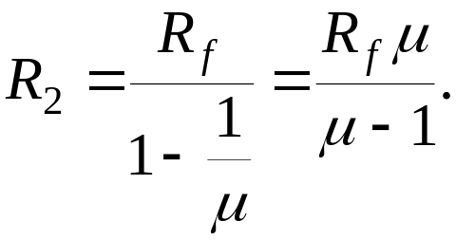
The resistor value R2 usually doesn’t matter, although we can solve for it, if it does. Why doesn’t it matter? It usually does not matter because the way we know the ratio μ is that we have a voltage dependent voltage source. This source ends up in parallel with R2. Then, the R2 does not affect the rest of the circuit.
This is more generally useful that it might seem. We often have such a feedback type situation, and we can find the equivalent resistance for the input side in this way. It also works for inductances, capacitances, and impedances.
Let’s do some examples.

In the Dual to Miller’s Theorem, we have a resistance, say Rf, as a part of 2 loops, where the ratio of the loop currents in those loops is known. Generally, this only happens when we have a dependent source or something like it.
We call this ratio ß, and then we argue that the outside world cannot tell the difference as long as the voltages in the two loops through Rf do not change. We can make this happen by connecting two new resistors, in the two loops, with the appropriate values.
What values would these resistors have? To find the first value, R1, we would note that the same voltage must be across R1 in its new position, as went across Rf before. Thus,
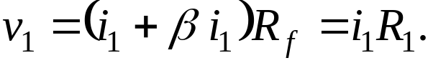
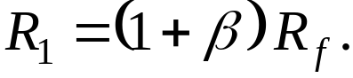 If we solve this for R1, we get
Now, let’s solve for R2. We follow the same approach, and find that
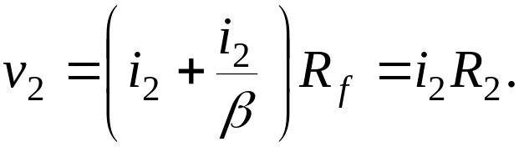
Now, again, we can solve for R2, and get
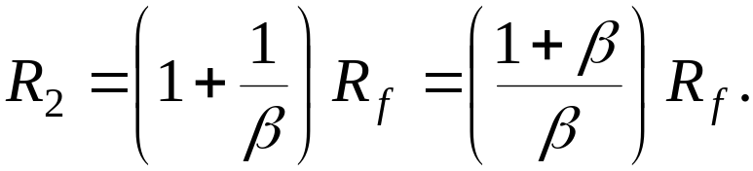
The resistor value R2 usually doesn’t matter, although we can solve for it, if it does. Why doesn’t it matter? It usually does not matter because the way we know the ratio β is that we have a current dependent current source. This source ends up in series with R2. Then, the R2 does not affect the rest of the circuit.

Remember, this is in itself an equivalent circuit. Therefore, it is equivalent with respect to the “outside world”, only.

Let’s do some more examples.

h Parameters
You may have noticed that some transistors are labeled with a value called hfe. What is this? This is handled briefly in Section 2.9, and in the Nilsson and Riedel text in Chapter 19.

It comes from a different way of modeling transistors. The premise is that when you have a 2 port network, you can model it with a Thevenin or Norton equivalent at the input, and with a Thevenin or Norton equivalent at the output. Now, since there are two ports, the input might depend on the output situation, and the output might depend on the input situation. So, we use dependent sources.
If we take just one example of this, we might take a Thevenin’s equivalent at the input, and a Norton’s equivalent at the output.
Draw the h parameter equivalent.
The h’s are called the h parameters. Note that ho is a conductance.
This is only one of several ways of doing this, but it is most commonly used in electronics, so we will ignore all the others.
Now, we can model transistors using these parameters. A transistor has 3 terminals, but a 2 port network has 4 terminals. We do this by using one terminal twice.
If we use the emitter terminal twice, we indicate this by adding e to the subscript.
Draw the h parameter equivalent for the emitter common.
This is the most common situation. There are 5 other kinds of parameters, and for each, we can choose 1 of 3 different terminals to be common. Thus, we could have had zic or gob as parameters, and they would have been just as good as hie.
Now, if hr is small enough to be neglected, we can redraw this as follows:
Draw the h parameter equivalent for the emitter common, with hre set = to zero.
Does this look familiar? It should. This is the model that we derived earlier from the transistor characteristic curves. We note that
hie = rπ
1/hoe = ro
hfe = β
Therefore, when you see hfe, you are just seeing another notation for β.

Formal Reports
There are several problems that have occurred with the formal reports in the past. Let’s talk about some of them.

1. Use of references, or failure to adequately reference other people’s work.
a) Each reference must have a page number or other mechanism for pointing the reader to the exact location of the source. Many students simply referenced a book, without a specific page number being included, or a range of pages was indicated. This is not sufficient. Each reference must point the reader the exact location for the source being used.
b) Several people used figures from handouts, from the text, from my lecture notes, or from another student, without a reference being present. This is plagiarism. If you wish to take a figure from any source, and include it in your report, you must indicate this clearly. The easiest way to do this is to place a reference at the end of the caption, indicating the source. It should be noted that I would prefer that you draw your own figures, but this is a minor preference. The requirement that you not plagiarize is a major issue.

2. You must attach a signed Formal Report Submission Form to the front of your report. If it is not present, I will reject the report without reading it.

3. Several students had no quantitative information in their abstract. This is not appropriate. Generally speaking, most technical reports should have some numerical results in the abstract. This rule is widely ignored, but this does not make it acceptable to perpetuate an inappropriate practice.

4. Someone should be able to read your report. Thus, your results section must not be just data. All figures must be referenced in the text. Your appendix must not be just data. Your equations need to be included in your sentences, and punctuated as if they were in your sentences.

The following instructions are adapted from a memo sent by A. B. El-Kareh, an Associate Dean here, in 1980. I offer them for your consideration.

- No sentence fragments.
- Eschew obfuscation.
- Proofread carefully to see if you any words out.
- Avoid commas, that are not necessary.
- Avoid run-on sentences they are hard to read.
- Verbs has to agree with their subjects.
- Don’t use contractions in formal writing.
- Do not overuse exclamation points!!!
- And do not start a sentence with a conjunction.
- If you reread your work you will find on rereading that a great deal of repetition can be avoided by rereading and editing.
- Do not use no double negatives.
- Use the semicolon properly, always use it where it is appropriate; and never where it isn’t.
- Also avoid awkward or affected alliteration.
- Be consistent in your use of tense. If you start in one tense, you stayed in that tense.
- Work as hard as you can to find ways to reduce as much as possible the number or words, phrases, or sentences needed to convey your ideas, thoughts, and concepts, and by doing so you will make your paper be brief and easier to understand as a result.
- Reserve the apostrophe for it’s proper use and omit it when its not needed.
- Double space after periods .Single space after commas ,and don’t put any spaces before either .
- Hyphenate between syllables and avo-
id un-necessary hyphens.

